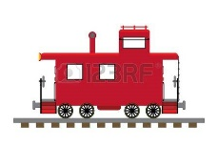
City of Williamson
Waste Services
Ashley Glen Phase 2 and Fox Tales Subdivisions
71 Midland Street - (770)227-8380
clerk@cityofwilliamsonga.org

Name______________________ Acct. #_________________Date_____________________
Physical address ______________________________ Lot # _________________________
Mailing address_______________________________________________
Phone (home)___________________(cell)_____________________email________________________

Deposit information

$40.00 Deposit

Information verification
Photo ID___________________
Lease agreement start date______________
List two relatives that do not live with you
Name_____________________________Phone___________________________
Name_____________________________Phone___________________________

Applicant Agreement: I agree to be fully responsible for all utility charges assessed to me at this property. I agree to promptly pay for utility services received according to the schedule of utility rates implemented by the City of Williamson. I agree to comply with all City of Williamson ordinances and regulations, and services procedures and guidelines. Applicant understands that the account security deposit collected to open a new account will be refunded only to the applicant named above and only after the account is closed and all account charges have been satisfied.

X_______________________________________________________Date_________________________

E-billing available- see clerk for more information.

Water service through
Pike County Water Authority
770-567-7287; pcwsa@bellsouth.net; 70 Gwynn St. Zebulon

